**Creating a Relational data base**

Schema of the Relational database in the file “Relational database schema”

Creating Tables and Populating with Data

1.Table- Owner_SaikrishnaG

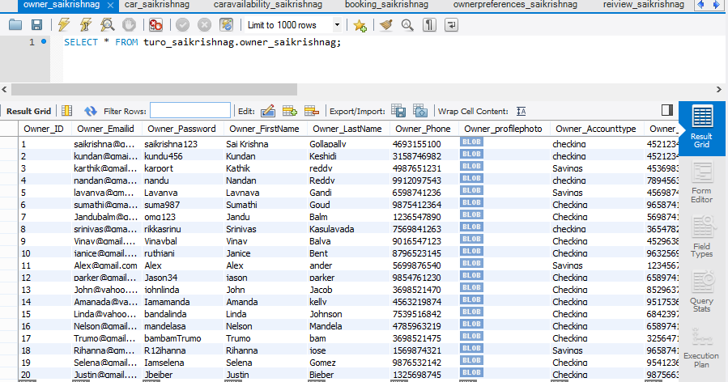

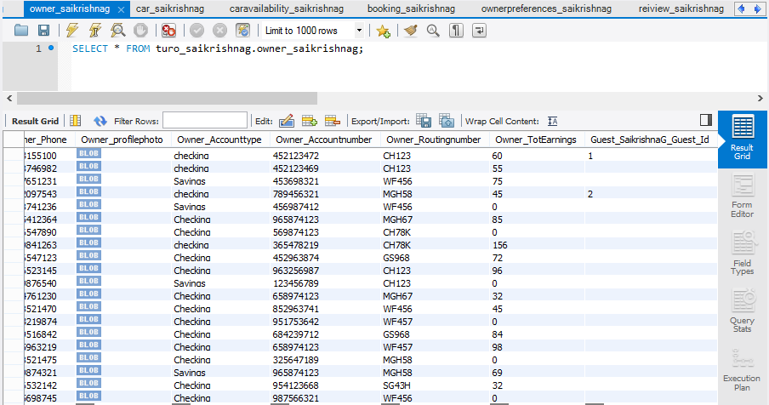

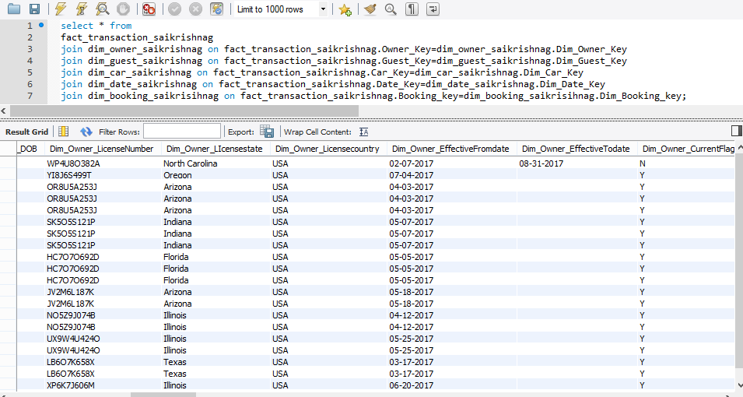

2.Table – Guest_SaikrishnaG

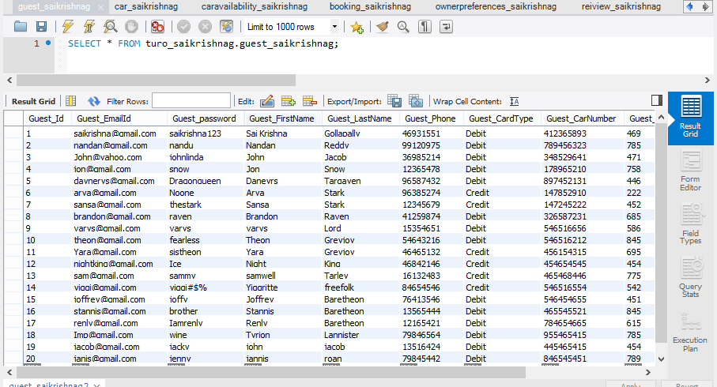

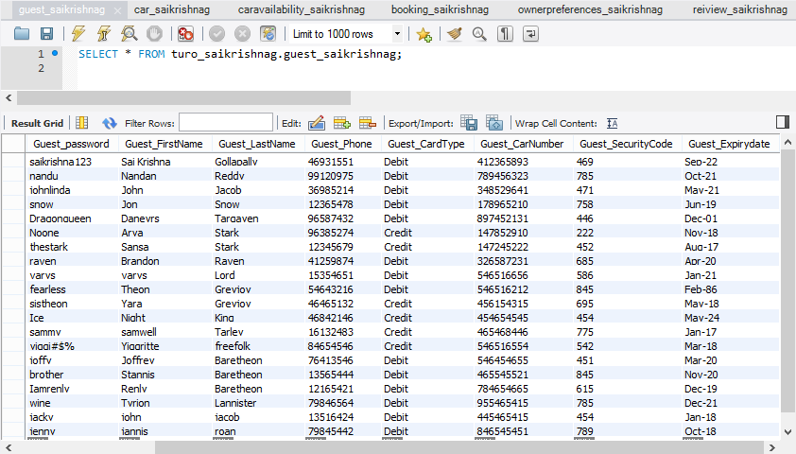

3.Table- Car_SaikrishnaG

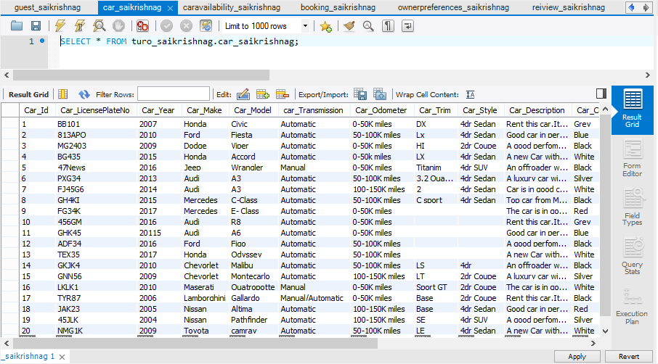

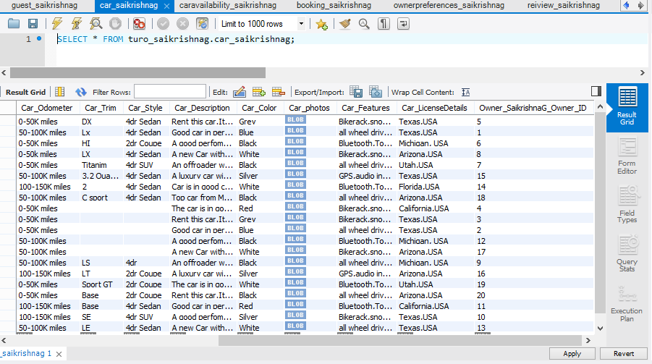

4.Table-CarAvailability_SaikrishnaG

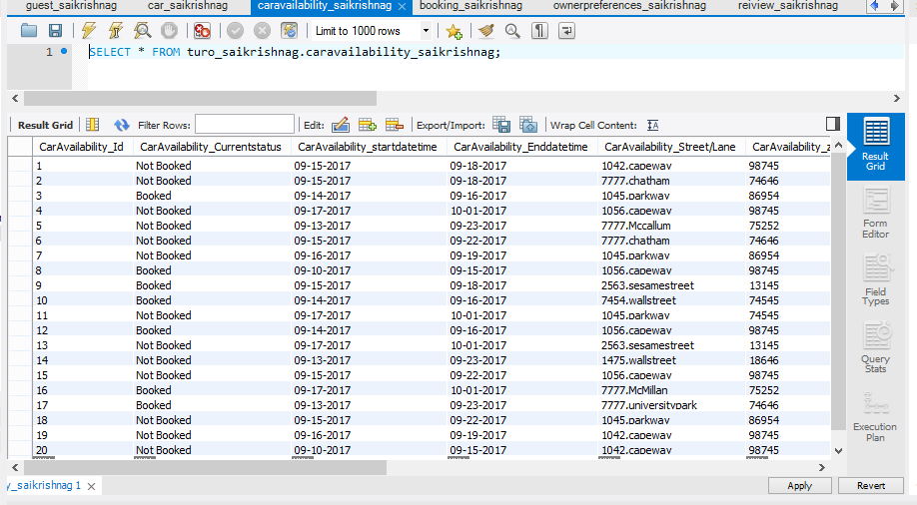

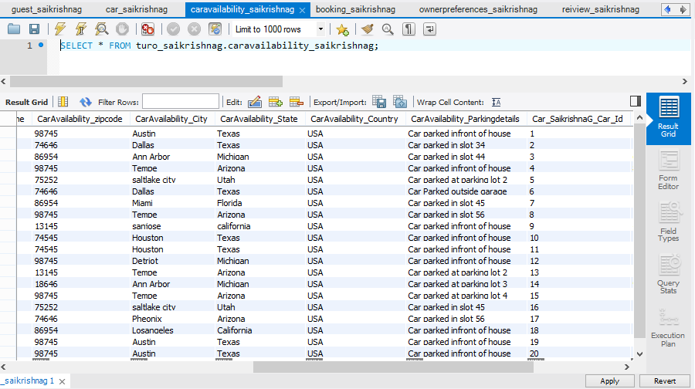

5.Table-Booking_SaikrishnaG

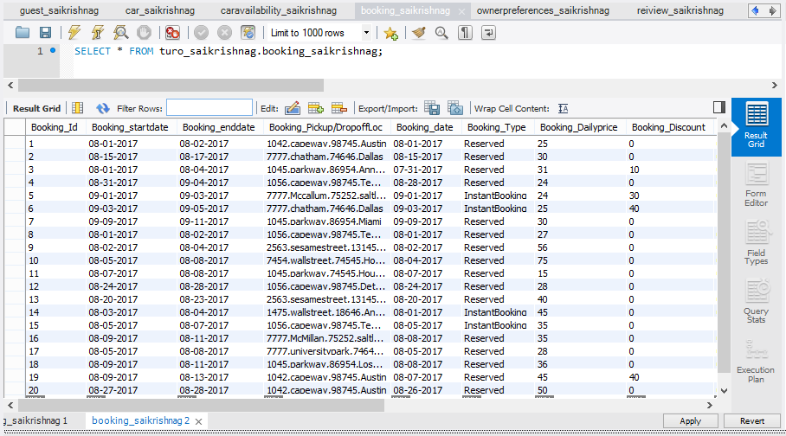

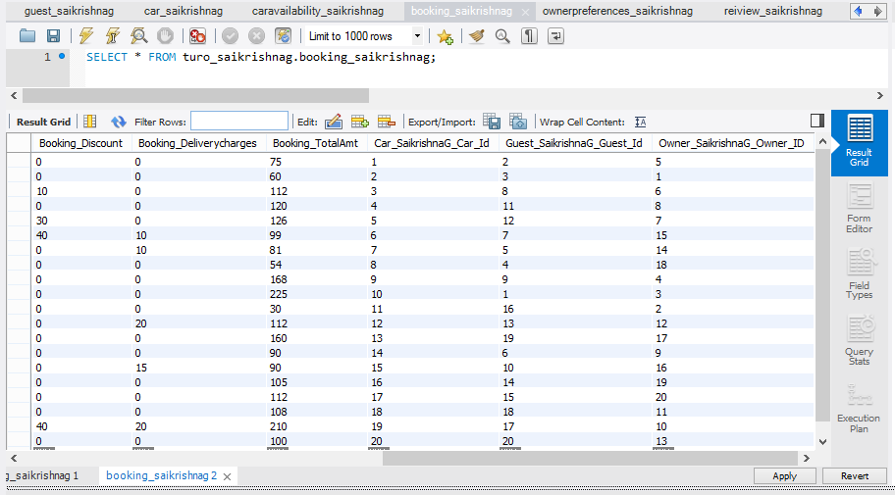

6.Table-Ownerpreferences_SaikrishnaG

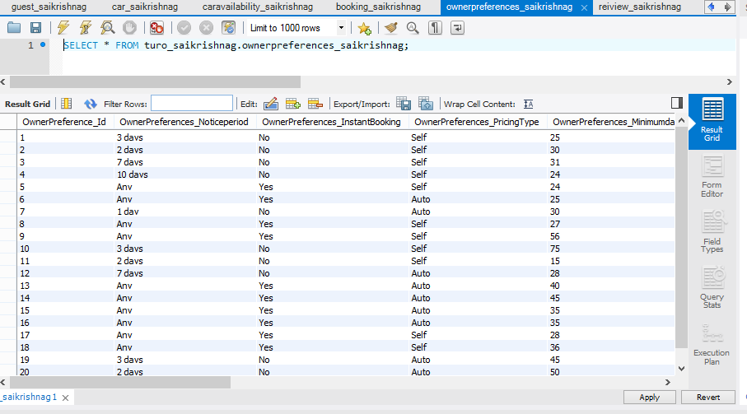

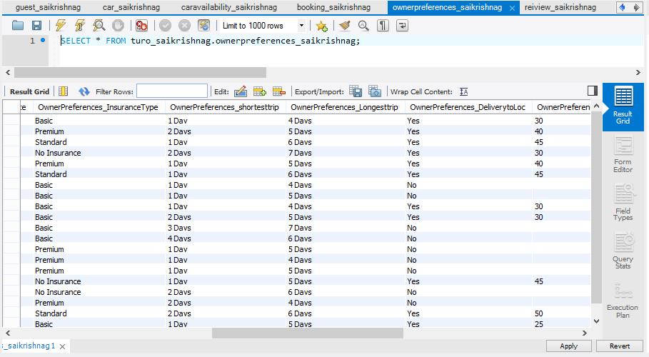

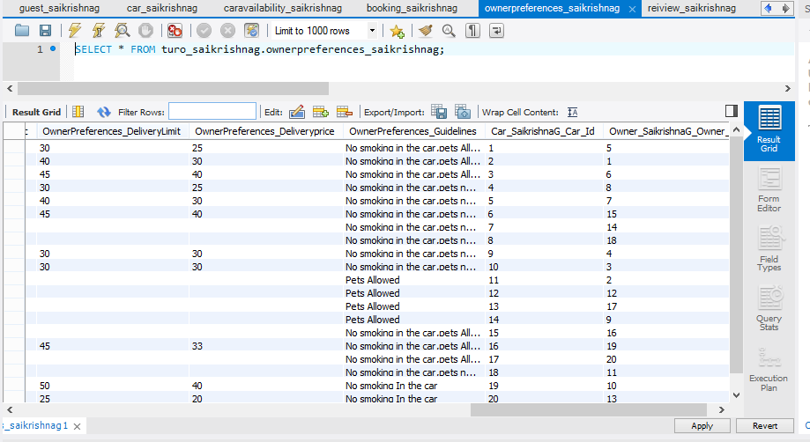

7.Table-Review_SaikrishnaG

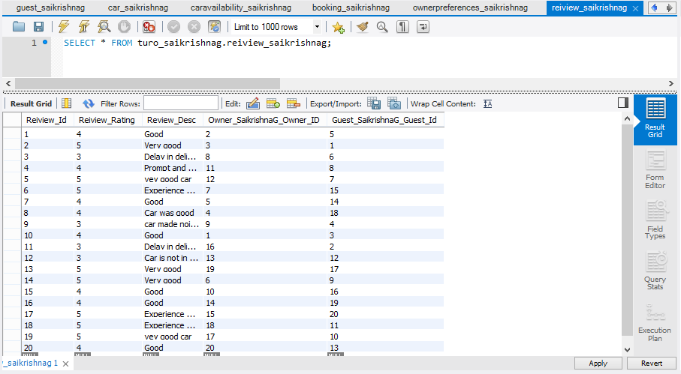

**CREATION OF DATAWAREHOUSE IN MYSQL**

The schema of data warehouse in file “Datawarehouse.mwb” file

1)Dim_Owner_SaiKrishnaG

Owner Dimension modeled as Type 2 SCD with Effective from date and Effective to date attributes which inform the details of owner are as per the record in those dates and CurrentFlag indicates the Current details of the owner.

Record with Key #9999 is a dummy record to handle the null values arise in the fact table .

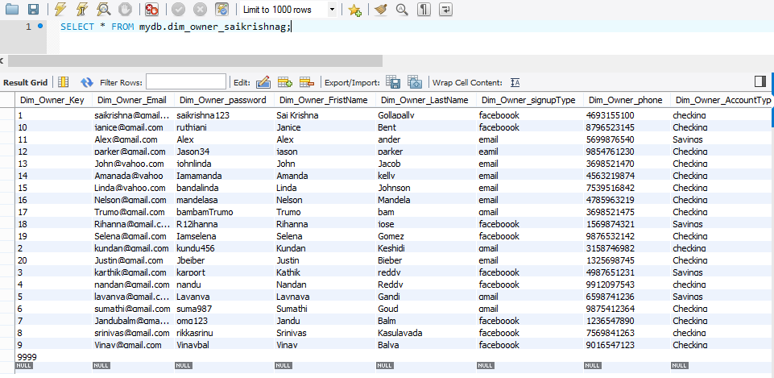

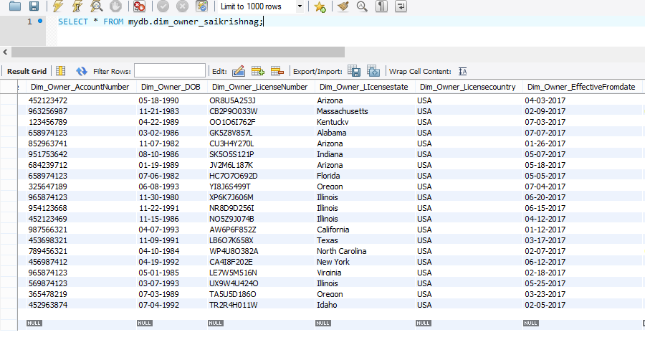

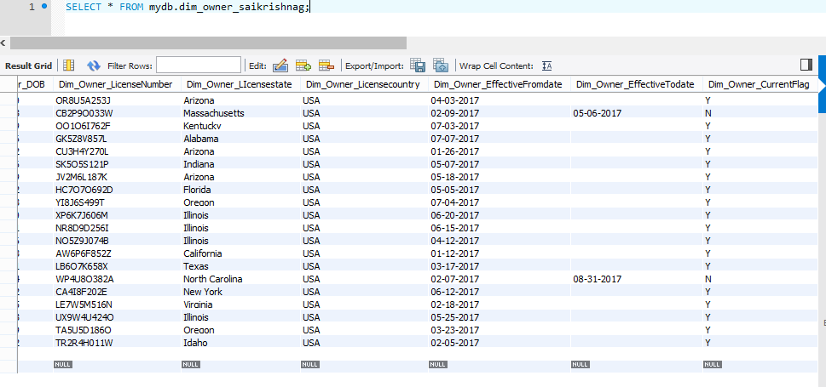

2)Dim_Guest_SaikrishnaG

Guest Dimension ,It is also modeled as Type 2 SCD to incorporate the changes in the details of the Guest over time.

Record with Key #2222 is a dummy record to handle the null values arise in the fact table .

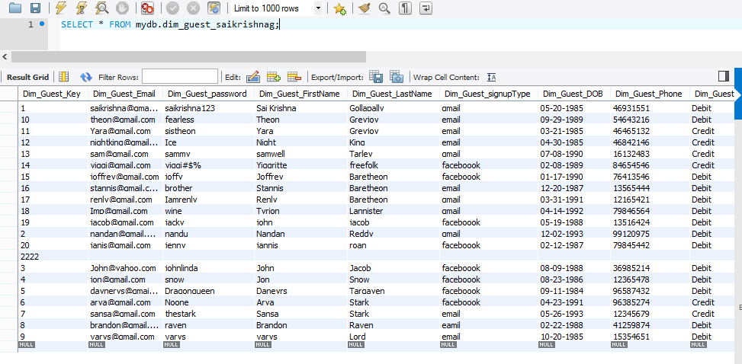

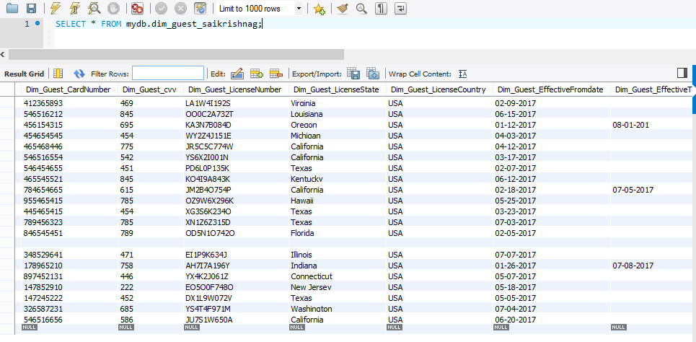

3)Dim_Car_SaikrishnaG

Car Dimension

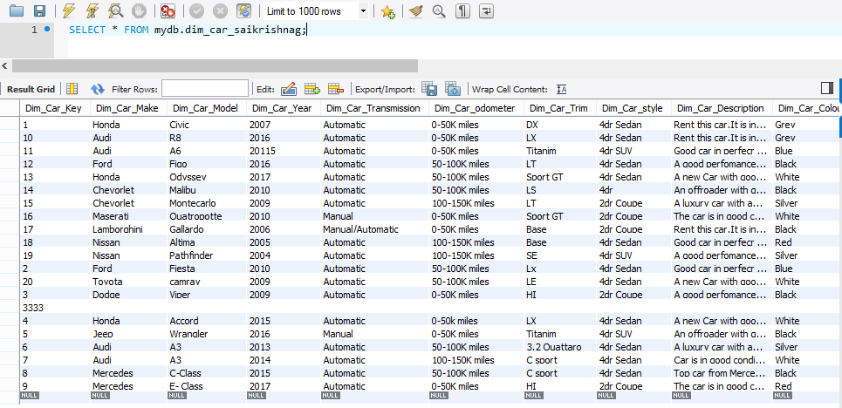

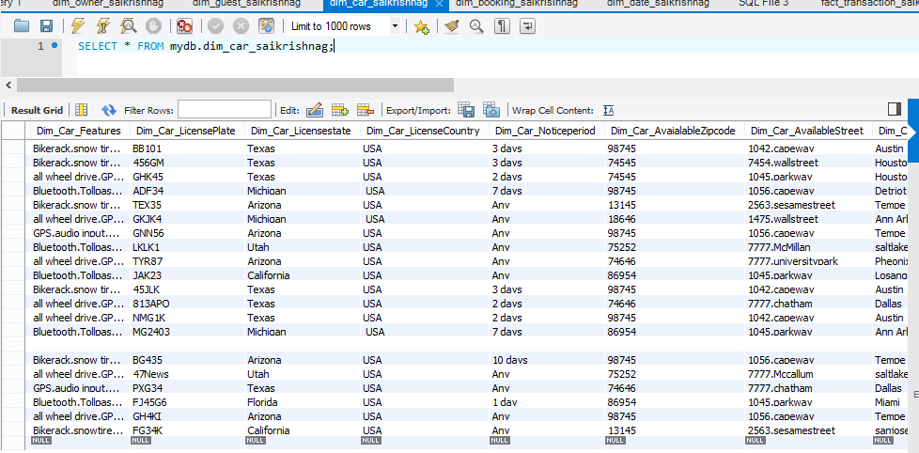

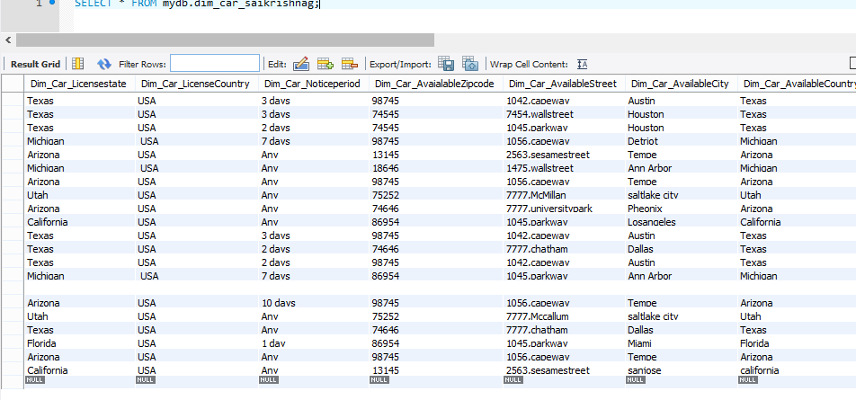

4)Dim_Date_SaikrishnaG

Time Dimension

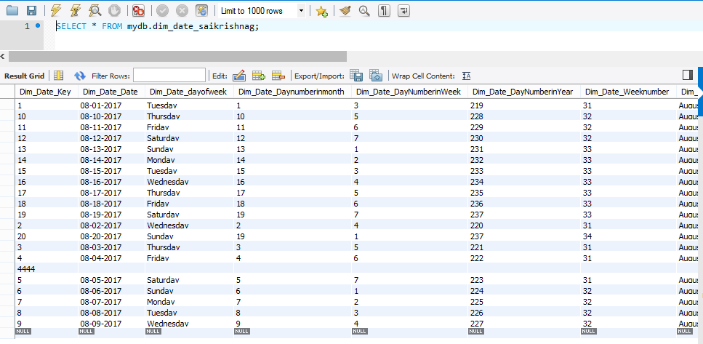

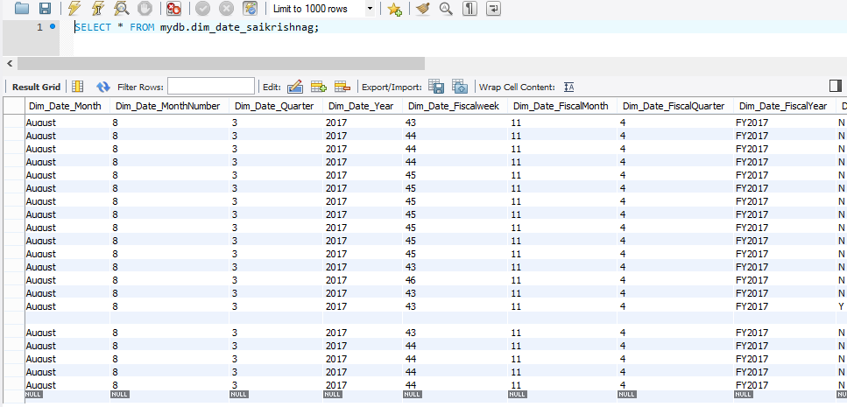

5)Dim_Booking_SaikrishnaG

Booking Dimensions captures details releated to Booking.

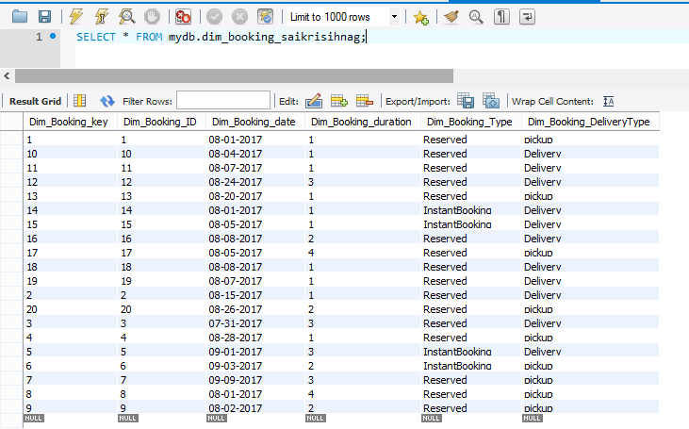

1) Fact_Transaction_SaiKrishnaG

Grain of the Fact_Transaction_SaiKrishnaG Table is per owner per guest per car per booking per day per charge.

By grouping owner,guest,car,booking we can get the amount charged for the trip.

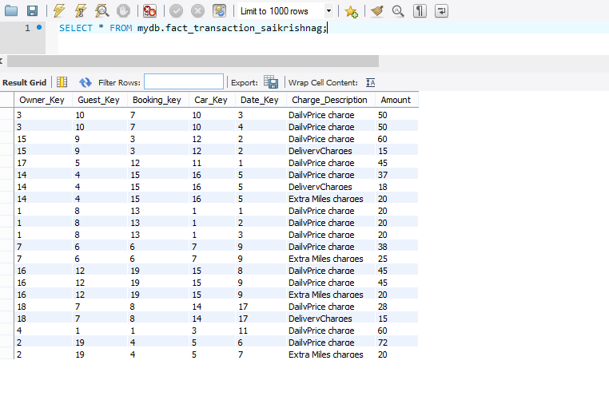2) Fact_Reiview_SaiKrishnaG

Grain of the Fact Table Fact_Review_SaikrishnaG is per owner per Guest per car per review.

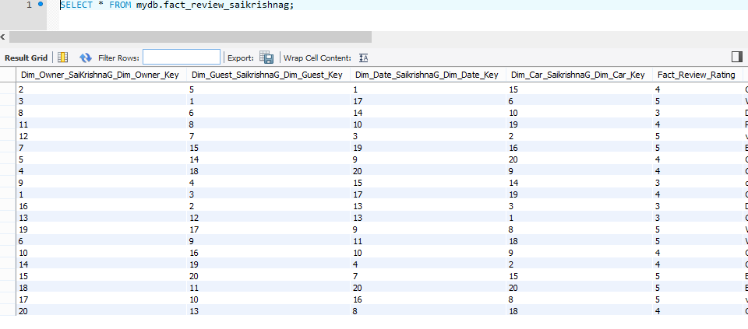

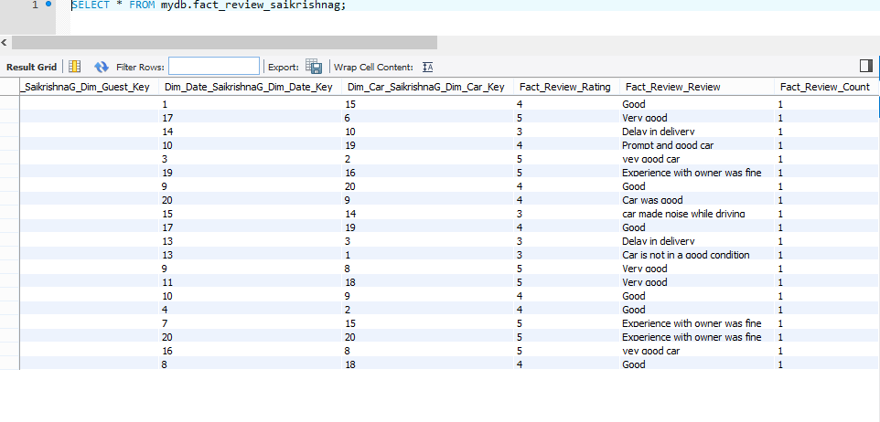3)Fact_OwnerShare_SaiKrishnaG

Grain of the fact table is per owner per car per payment

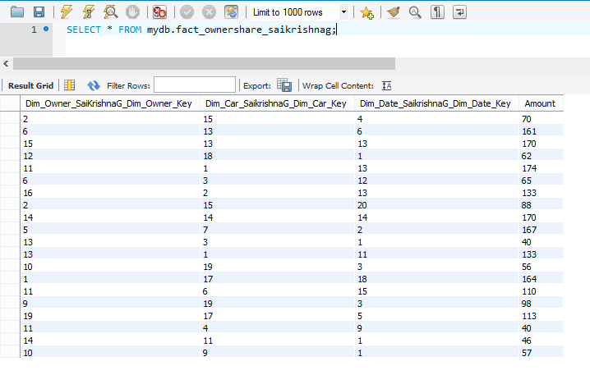

Below is the main Fact Table i,e Fact_Transaction_SaikrishnaG from which the queries such as Total Revenue per car booked per Guest by city, zip, region, by month can be answered.

After joining all dimensions with the fact table the data is as below.

There is no duplicity of data and each record is unique. 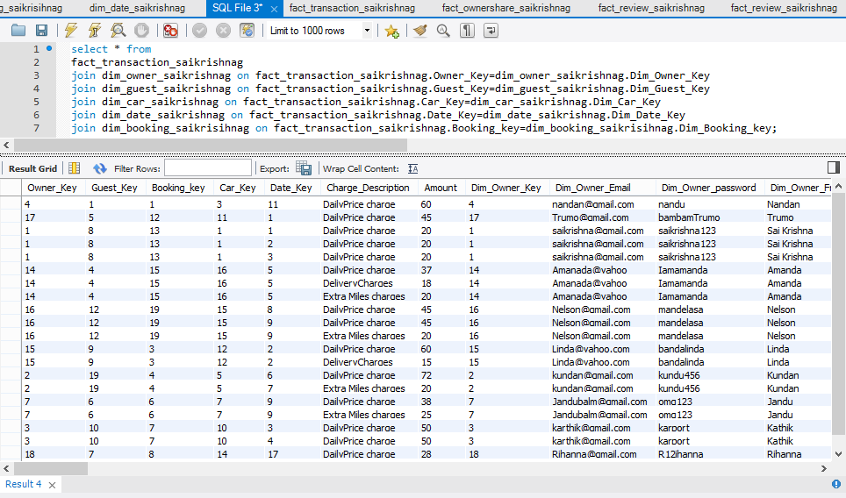

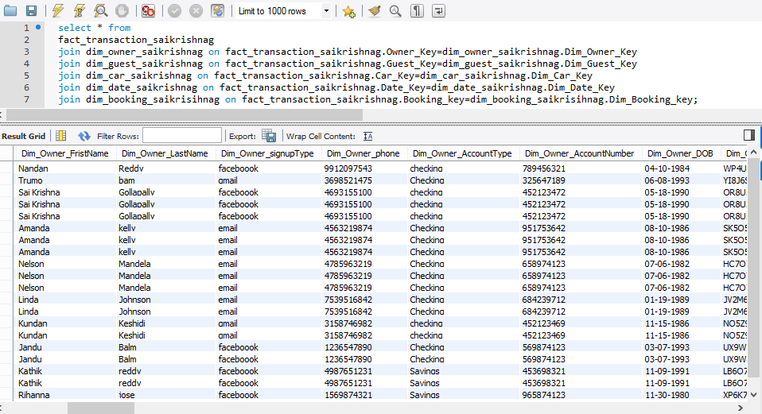



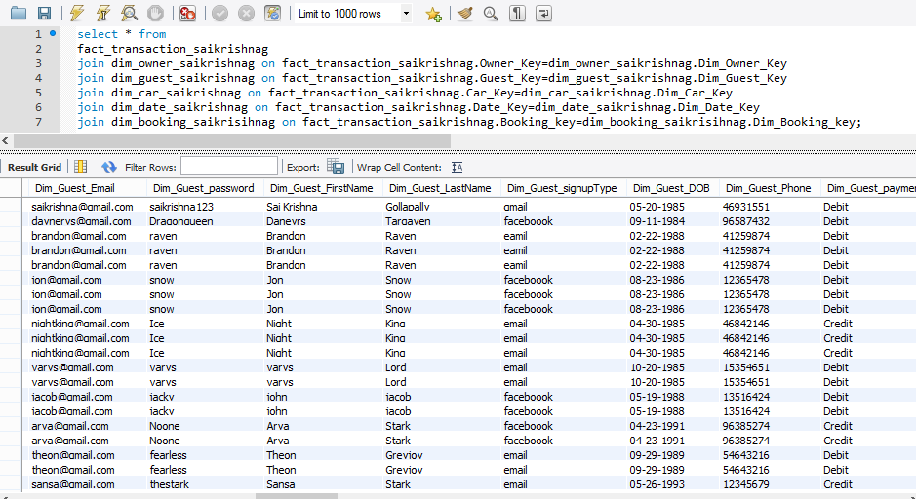

**3.Using SAP Business Objects Tool**

**The designs are in the files “ Dimensionalmodel-UDT” and “ERmodel-UDT”**

ER model Universe in UDT

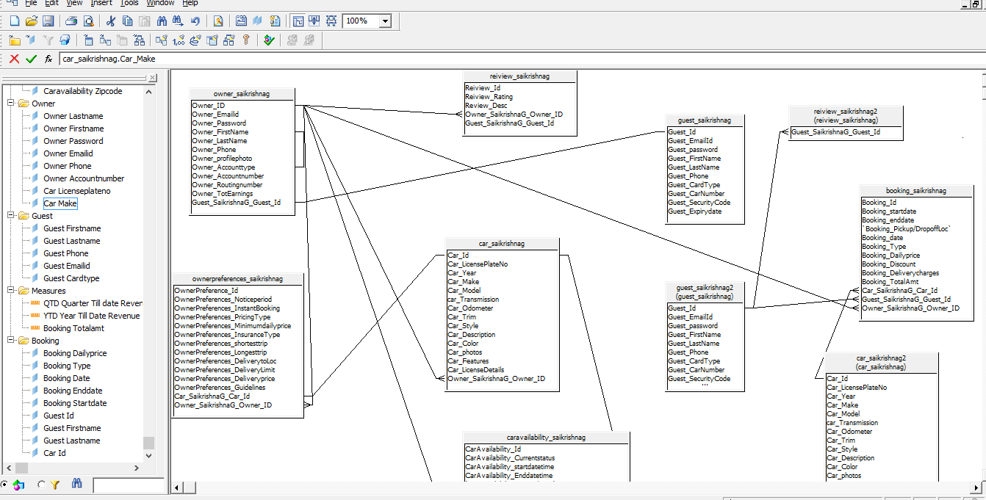

Object Panel Of ER Model in UDT

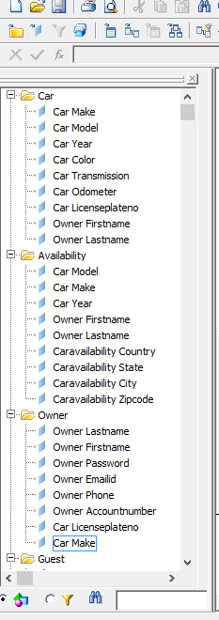

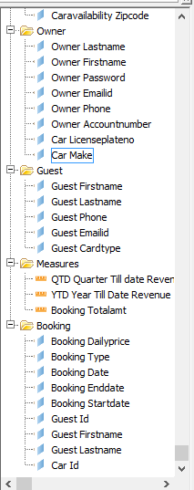

Query of QTD (ER model ) in UDT

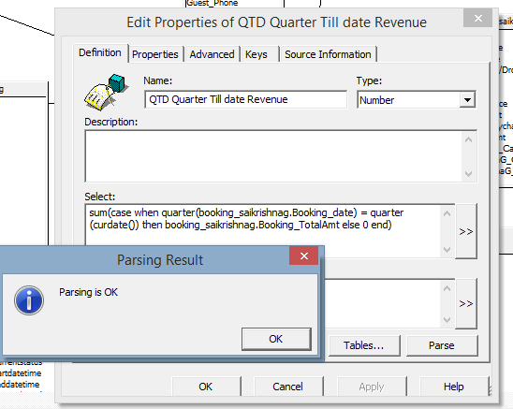

Query of YTD in UDT

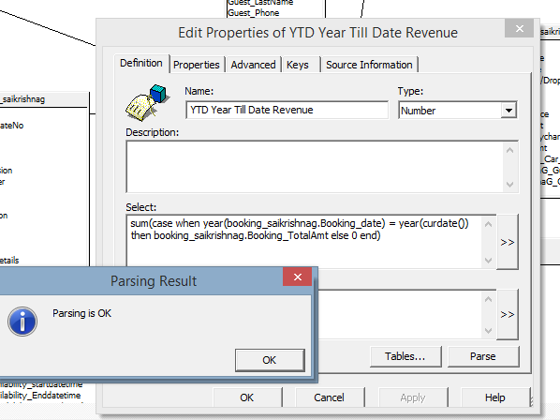

Query of Last month revenue collected

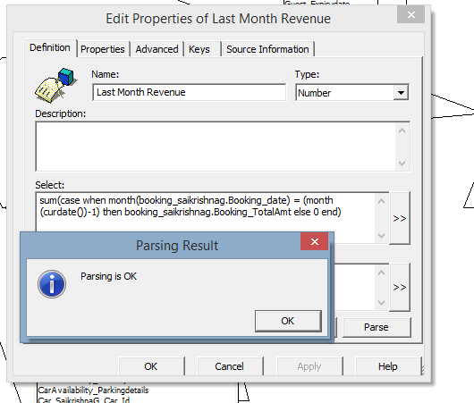

Integrity Check of ER model Universe in UDT

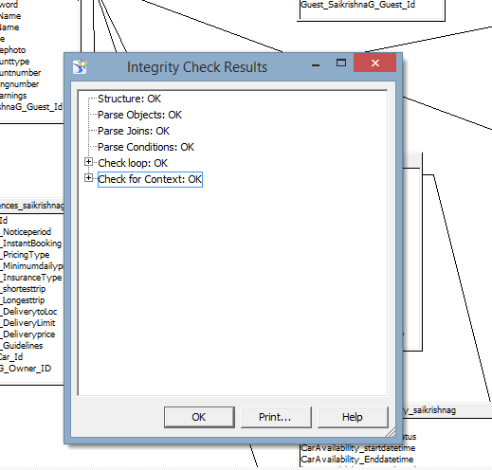

Dimensonal model Snapshot in UDT

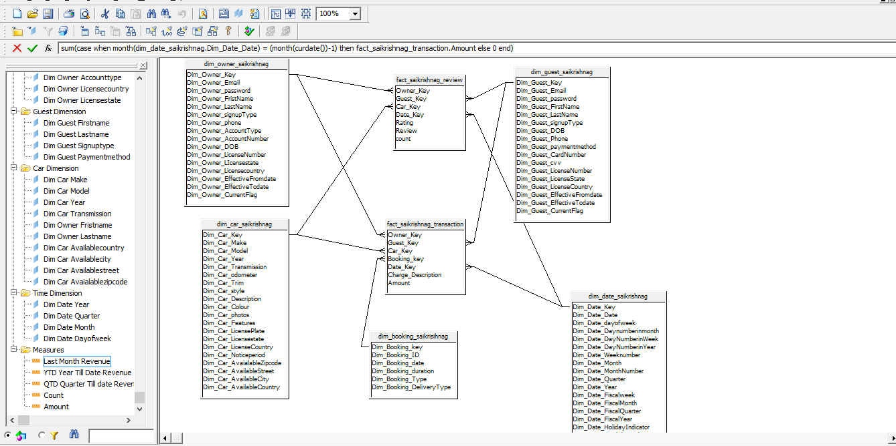

Year Till date Query for Dimensional model in UDT

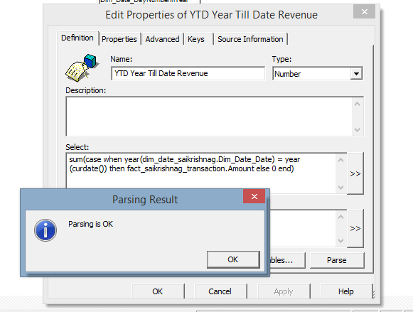

Query for YTD of Dimensional model in UDT

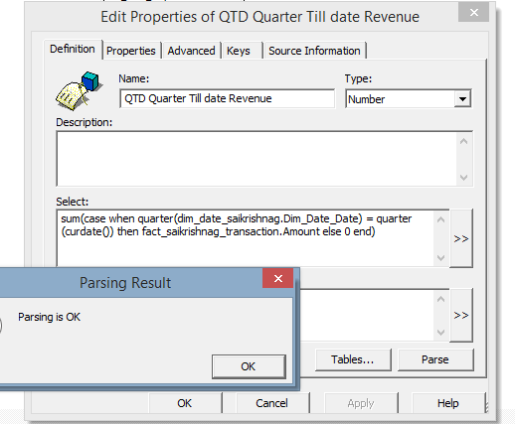

Last Month Revenue snapshot in UDT(Dimensional model)

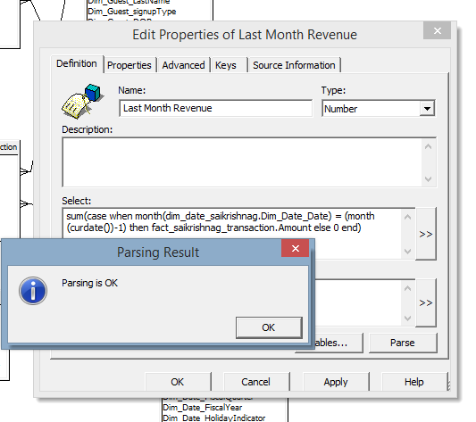

Integrity Check Result

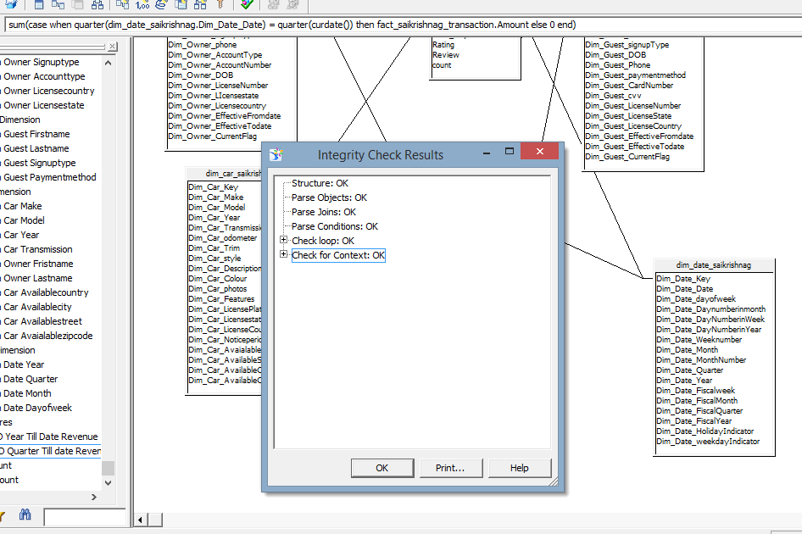

Snapshot of Universe of dimensional model in IDT

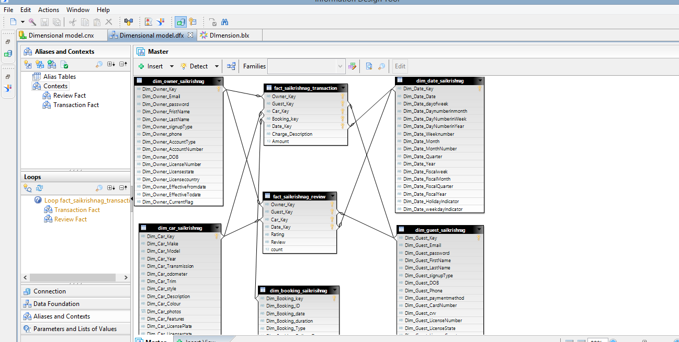

Snapshot of YTD, QTD of Dimensional model

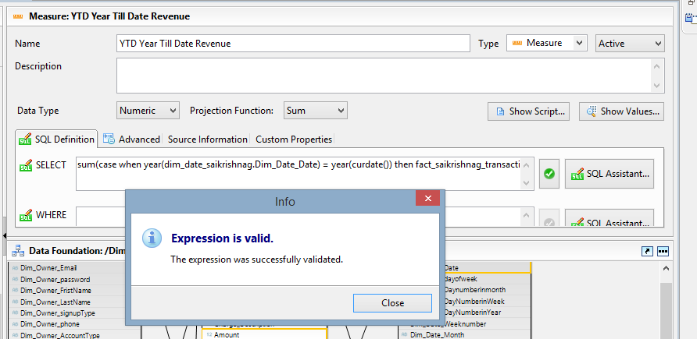

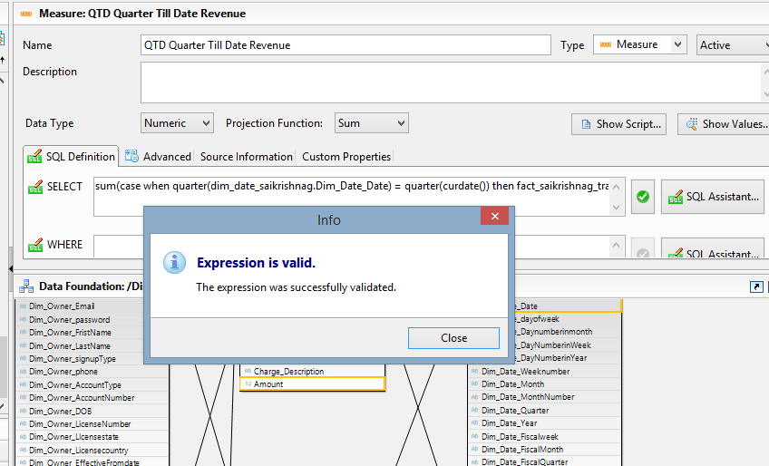

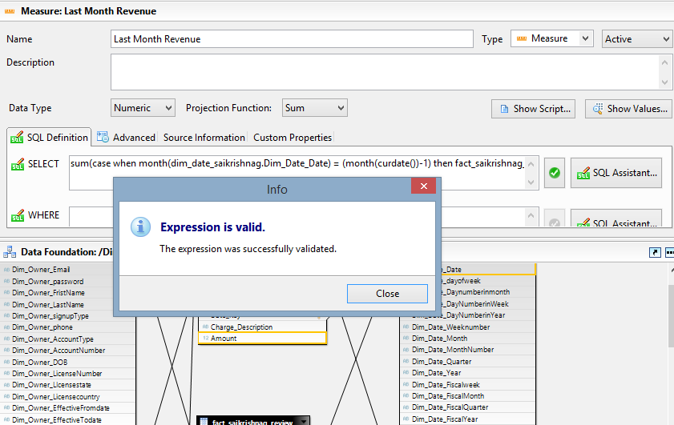

Integrity Check of Dimensional model in IDT

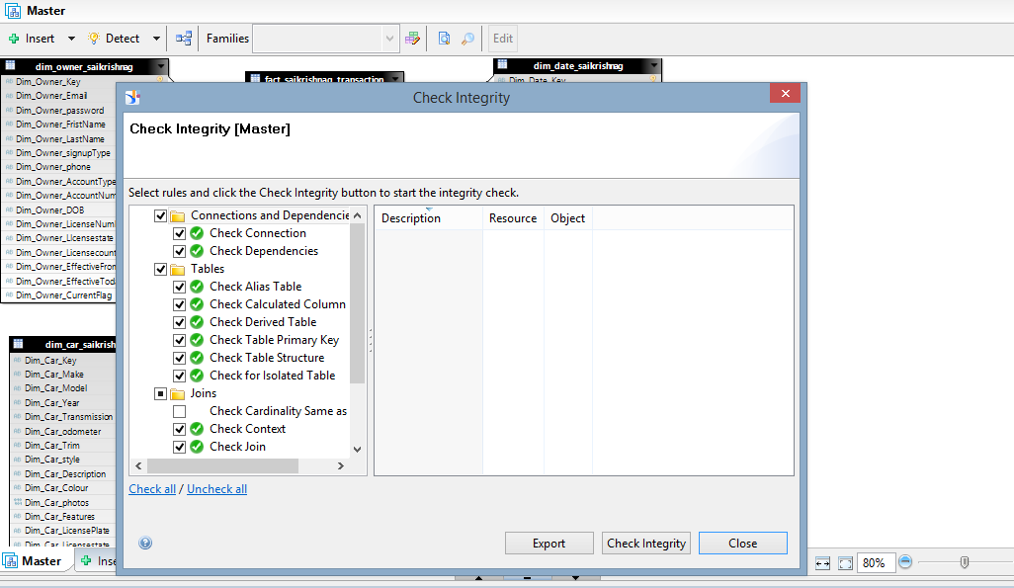

**Sample SAP Webi Reports**

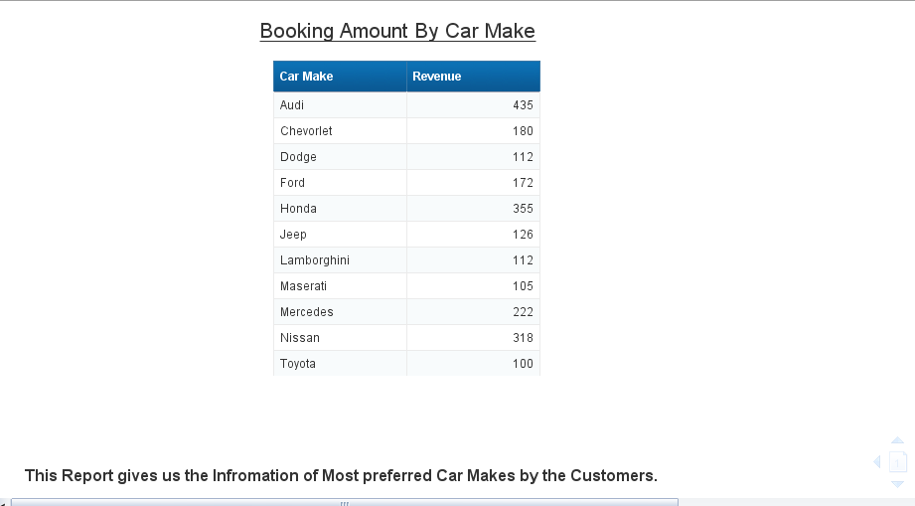

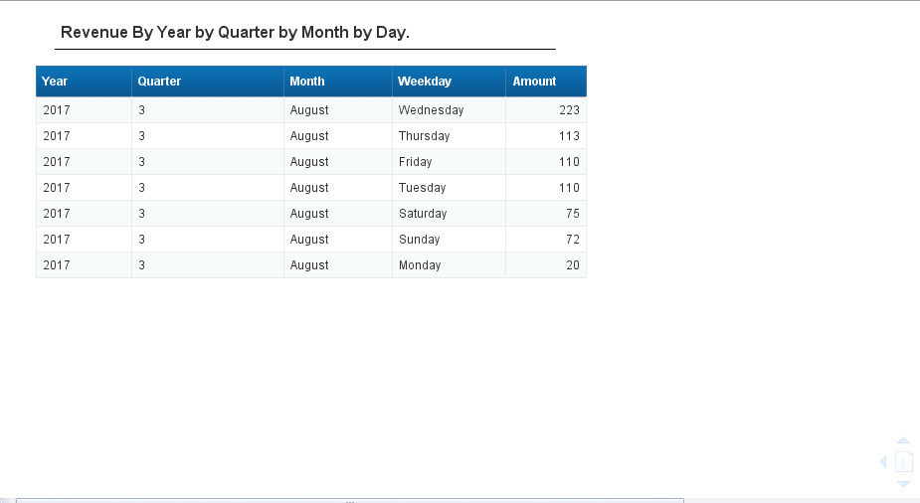

Dashboard in Webi

